1. create a table named tblParents in Student schema, the Create table definition will be as following(minimum 20 entry is required )
• parent id
• parents name
• city
• age
• annual income
• occupation
• emailed

Ans:
create database Studenttestdb;
use Studenttestdb;
Database changed
tblParents(Parent_Id int primary key, Parents_Name varchar(30), City varchar(40), Age int, Annual_Income int, Occupation varchar(40), Email_Id varchar(50));
insert into tblParents(Parent_Id, Parents_Name, City, Age, Annual_Income, Occupation, Email_Id) values (1, 'Dilip Birajdar', 'Solapur', 43, 50000, 'ShopKeeper', 'dilipbirajdar12@gmail.com'),(2, 'Kasim Patel', 'Pune', 45, 100000, 'Farmer', 'kasimpatel3@gmail.com'), (3, 'Ames Smith', 'New York', 44, 200000, 'Buisness Man', 'smithames45@gmail.com'), (4, 'Pravin Rahman', 'Delhi', 48, 500000, 'Buisness Man', 'pravinrahman69@gmail.com'), (5, 'Ramesh Patil', 'Mumbai', 46, 700000, 'Teacher', 'patilramesh02@gmail.com'), (6, 'Mary Hanes', 'Delhi', 50, 900000, 'Professor', 'hanesmary097@gmail.com'), (7, 'Jaffery Rubin', 'Washington', 49, 1200000, 'Business Man', 'rubinjaffery50@gmail.com'), (8, 'Jamie Jones', 'Kolkatta', 52, 600000, 'Teacher', 'jamie234jones@gmail.com'), (9, 'Linda Foster', 'London', 55, 700000, 'Business', 'fosterlinda89@gmail.com'), (10, 'Robert Redmond', 'Paris', 49, 800000, 'Professor', 'redmond55robert@gmail.com'), (11,'Raj Malhotra','Mumbai',49,1000000,'Actor', 'malhotraraj07@gmail.com'), (12,'Mayank Shukla','Patna', 54, 400000,'Employee','shukla05mayank@gmail.com'),(13,'Aryan Avasthi','Rajkot', 46, 700000,'Servant','avasthia2708@gmail.com'),(14,'Vinayak Patil','Kolhapur', 43, 550000,'Shopkeeper','patilvinayak@gmail.com'),(15,'Amitesh Jadhav','Nashik', 51, 400000,'Professor','jadhavami789@gmail.com'), (16, 'Vinod More', 'Nashik', 39, 400000, 'Teacher', 'vinodmore45@gmail.com'), (17, 'Suraj Shinde', 'Washim', 38, 500000, 'Professor', 'surajshinde25@gmail.com'), (18, 'Vighnesh Kulkarni', 'Nanded', 41, 300000, 'clerk', 'vkulkarni78@gmail.com'), (19, 'Swapnil Katkar', 'Mohol', 47, 600000, 'Farmer', 'Swapnilk94@gmail.com'), (20, 'Dinesh Muthe', 'Pune', 53, 450000, 'Security', 'dmuthe375@gmail.com');
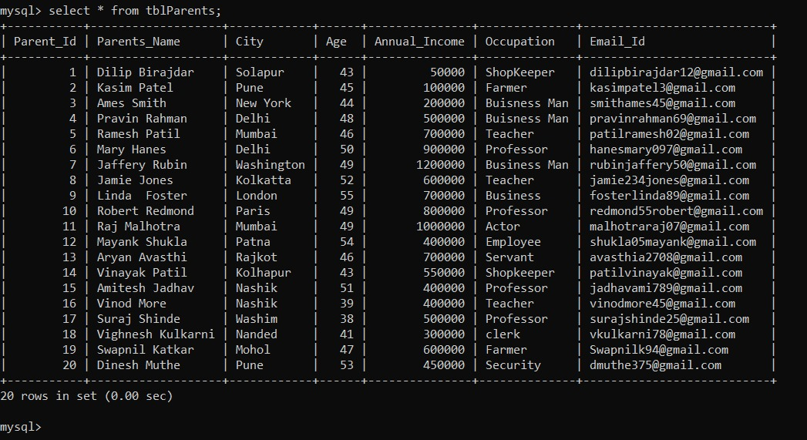

2. update email id of each parents as “NA”.
Ans:
update tblParents set Email_Id='NA';
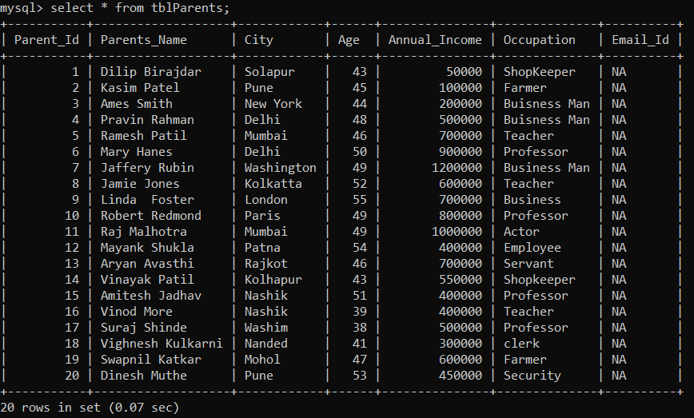

3. count number of parents whose annual income is more than 6 lakhs.
Ans:
select count(Annual_Income) from tblParents where Annual_Income>600000;
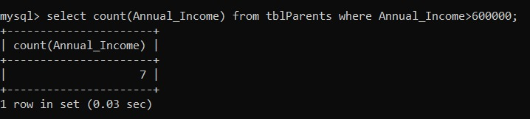

4. Select parents who are living in city Ahmedabad, Delhi, Mumbai, Chennai, Banglore.
Ans:
select * from tblParents where City='Ahmedabad' or City='Delhi' or City= 'Mumbai' or City= 'Chennai' or City= 'Banglore';
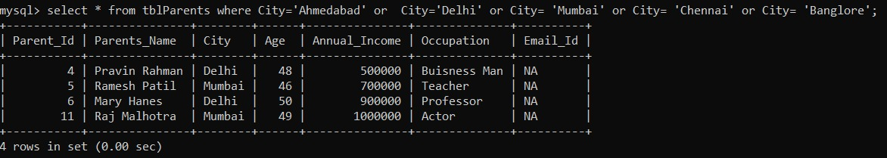

5. Write a SQL statement to select parent whose annual income is less than 5 lakhs otherwise age is more than 45.
Ans:
select * from tblParents where Annual_Income<500000 or Age<45;
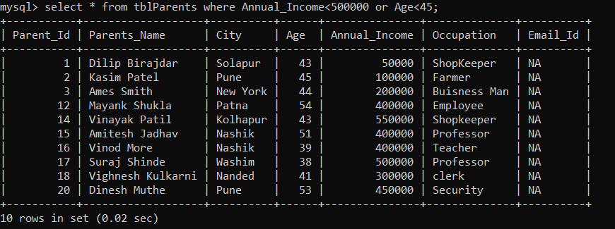

6. Create student table with studentid, student name, Maths, science marks, parent id here parent id is foreign key and make connected with parents table using primary key & foreign key
Ans:
create table Student(Student_Id int PRIMARY KEY, Student_Name varchar(30), Maths_Marks int, Science_Marks int, Parent_Id int, FOREIGN KEY (Parent_Id) references tblParents(Parent_Id));
describe Student;
